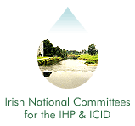
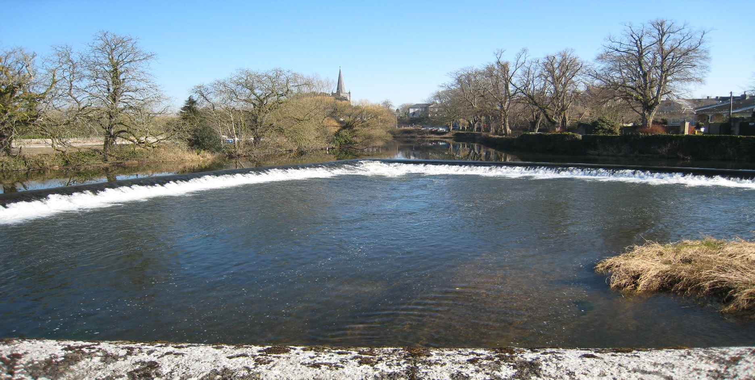
Irish National Hydrology
Conference 2022
Climate Change and Adaptation

Final Announcement

Tuesday, 15th November 2022

The Hodson Bay Hotel

Athlone, Co. Roscommon

Introduction
The National Committees of the IHP/ICID invite you to Athlone for the 23rd National Hydrology Conference to be held on Tuesday 15th November 2022 at the Hodson Bay Hotel. This event is Ireland's leading Conference devoted to Hydrology providing a unique forum for attendees to share policy developments, research results, and practical solutions to engineering hydrology and related issues.

Conference Theme ..
This year’s conference will focus on Climate Change and Adaptation. Understanding hydrological processes which determine the relationship between humans and the environment is important when quantifying environmental changes and instabilities. The IHP/ICID recognises that the topic of climate change and adaptation is now gaining momentum amongst the scientific and political community, and it is an opportune time to address some of the relevant issues through our annual conference.

This year’s conference will entertain technical papers and posters that will address climate change, climate adaptation, and implications for floods, groundwater resources, and new developments in hydrology and modelling climate change impacts. These topics range from case studies, to practical applications of hydrological practices, to research focused projects.

Organisers
International Hydrological Programme (IHP) .
The UNESCO international scientific co-operative programme in hydrology and water resources, the IHP, was established to act as a catalyst to promote co-operation and research in the management of water resources, an issue which had been identified as a significant limiting factor for harmonious development in many regions and countries of the world.

International Commission on Irrigation and Drainage (ICID)
The mission of the ICID is to stimulate and promote the development of the management of water and land resources for irrigation, drainage, flood control and river training applications, including research and development and capacity building.
Conference Booking & Costs .
Demand for places at previous Conferences has been high. Places are allocated on a first-come basis, and pre-booking is essential (using the registration form on this page). The cost of attendance at the Conference is €130 per person (with a limited Student rate of €40), which includes refreshments and lunch. Invoices will be issued following receipt of registration forms requesting the reservation of a place. Receipts will only be issued upon demand.

Please note that we there will be no refund or waiver of invoice for cancellations received later than Friday, 11th November.

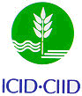

Irish National Hydrology
Conference 2022

Conference Opening
09:00 | Conference Registration (Tea, Coffee & Pastries)
10:00 | Welcome – Patrick O'Donovan, T.D., Minister of State for the Office of Public Works and Flood Relief.

Session 1: WATER RESOURCES RESEARCH AND APPLICATION
10:20 | WaterFutures – Modelling drivers, pressures, impacts and mitigation measures that influence water quality in a changing Ireland
 | Michael Bruen (University College Dublin)
10:40 | Conference Poster Presentations
 | Brief Introductions to posters on display in the exhibition area
11:20 | Discussion - Tea/Coffee

Session 2: HISTORICAL DATA AND PREDICTION
12:00 | Hydrometric data rescue for the extension of river flow records in Ireland
 | Kate de Smeth (University College Dublin)
12:20 | Seasonal Hydrological Forecasting: Appraising the skill of multiple methods in Ireland
 | Conor Murphy (Maynooth University)
12:40 | Effect of Trends on Regional Flood Frequency Growth Curve and At-Site Quantile Estimates
 | Uzzal Mandal (RPS Consulting Engineers)
13:00 | Discussion - Lunch

Session 3: EFFECTS OF CLIMATE CHANGE ON FLOODING IN IRELAND
14:20 | Assessing the vulnerability of groundwater floods in Ireland to a changing climate
 | Joan Campanyà (South East Technological University)
14:40 | Production of operational Climate Extreme Indices products at Met Éireann
 | Seánie Griffin (Met Éireann)
15:00 | Climate change and hydrology: Projected changes in hydrological regimes of Irish catchments from the CMIP6 ensemble of climate models
 | Conor Murphy (Maynooth University)
15:20 | Discussion
15:30 | Comfort Break

Session 4: WATER RESOURCES RESEARCH AND APPLICATION
15:40 | Hydrology of the Neale Flood Relief Scheme study area in South County Mayo
 | Conor Warner (Ryan Hanley)
16:00 | Assessment of the GPM IMERG estimates of rainfall seasonality over Ireland
 | Safa Mohammed (TU Dublin)
16:20 | Discussion
16:30 | Close

09:00 – 15:30 Poster Exhibition
Posters will be on display in the exhibition area all day during the breaks in the conference programme.

Registration / Further Information .
To register to attend the conference or to request further information, please complete the registration form and return (with payment to confirm a booking) to:
Contact: IHP/ICID Secretariat,
Office of Public Works, Head Office,
Trim,
Co. Meath, Ireland.
Tel: 046 942 6737
E-mail: nhc@opw.ie
All payments to be made by Electronic Fund Transfer (EFT)
BIC - DABAIE2D
IBAN - IE91DABA95167890052841
Please send remittance to receipts@opw.ie and reference the National Hydrology Conference.

Registration Form
Name:
Job Title:
Organisation:
Address:
Purchase Order No. (if applicable):
Tel: Fax:
E-mail:

