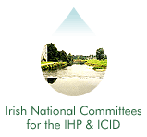
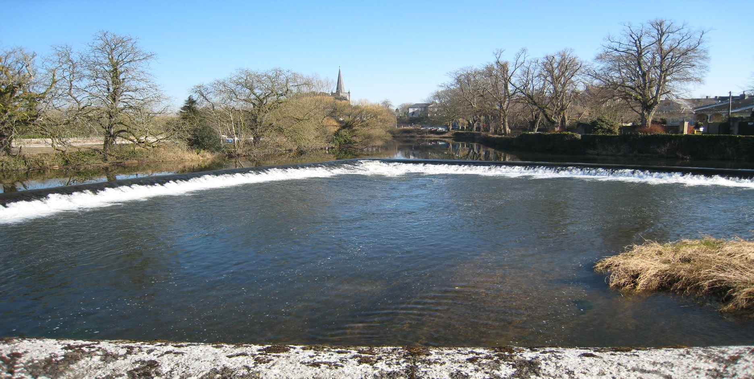
Irish National Hydrology
Conference 2022

First Announcement
Call for Papers & Posters

Tuesday, 15th November 2022

Hodson Bay Hotel

Athlone, Co. Roscommon
(with virtual meeting option)

Introduction
The National Committees of the IHP/ICID invite you to Athlone for the 23rd National Hydrology Conference to be held on Tuesday 15th November 2022 at the Hodson Bay Hotel. This event is Ireland's leading Conference devoted to Hydrology providing a unique forum for attendees to share policy developments, research results, and practical solutions to engineering hydrology and related issues.

Conference Theme ..
This year’s conference will focus on Climate Change and Adaptation. Understanding hydrological processes which determine the relationship between humans and the environment is important when quantifying environmental changes and instabilities. The IHP/ICID recognises that the topic of climate change and adaptation is now gaining momentum amongst the scientific and political community, and it is an opportune time to address some of the relevant issues through our annual conference.

We would like to invite strong, technical, papers/posters that deal with climate change, climate adaptation, remote sensing monitoring of climate variables, and implications for floods, droughts, water supply, groundwater resources, and new developments in hydrology and modelling climate change impacts. These topics can range from case studies, to practical applications of hydrological practices, to research focused projects.

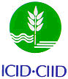
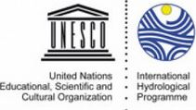

Who are the expected attendees?
- Local Authority Engineers and Planners
- Engineering Consultants, Researchers, Hydrologists, Environmental Engineers and Scientists
- Policy makers from all relevant fields
- Professionals involved with the implementation of the various EU water management Directives.

Conference Format .
The programme will consist of oral presentation of papers with discussion, and a poster/display session. Participants are invited to contribute through posters and oral presentations. While primarily an in-person event, it is expected that this year’s conference will be also broadcast online.

Call for Papers . .
Participants willing to contribute to the Conference through the presentation of a paper should submit a short abstract (maximum 600 words). The abstracts should be sent by e-mail to the Conference Secretariat by Friday, 12th August. The organising committee will review the abstracts and select those for oral presentation. The authors of the selected abstracts will be informed by Thursday, 25th August. The full papers should be submitted by 15th October for review.

Call for Posters ..
Participants willing to contribute through the provision of a poster display should submit a short summary (maximum 300 words) of the project or topic. The deadlines for submissions and the review and acceptance format and dates are as per the call for papers above.

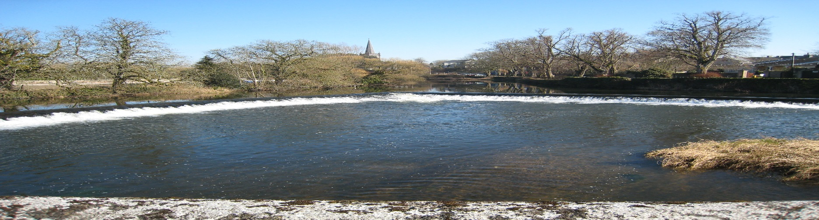
Irish National Hydrology
Conference 2022

Conference Booking & Costs .
The cost of attendance at the Conference is €130 per person (with a limited reduced Student rate of €40), which includes refreshments and lunch. We also offer a special rate of €70 per person (reduced to €20 for students) for online attendance. Invoices will be issued following receipt of registration forms requesting the reservation of a place. Receipts will only be issued if requested. Demand for places at previous Conferences has been high. Places are allocated on a first-come basis, and pre-booking is essential (using the registration form on this page).

Please note that there will be no refund or waiver of invoice for cancellations received later than Friday, 11th November.
Conference Programme ..
The Programme for the Conference will be confirmed nearer the date. It is currently envisaged that the Conference will run from 10 a.m. to 4:30 p.m. on the 15th November 2022

Registration / Further Information .
To register to attend the conference or to request further information, please complete the registration form (including indicating if intending to attend online)and return to:

Contact: IHP/ICID Secretariat,
Office of Public Works, Head Office,
Trim,
Co. Meath, Ireland.
Tel: 046 942 2472
E-mail: nhc@opw.ie

Organisers
International Hydrological Programme (IHP) .
The UNESCO international scientific co-operative programme in hydrology and water resources, the IHP, was established to act as a catalyst to promote co-operation and research in the management of water resources, an issue which had been identified as a significant limiting factor for harmonious development in many regions and countries of the world.

International Commission on Irrigation and Drainage (ICID) ..
The mission of the ICID is to stimulate and promote the development of the management of water and land resources for irrigation, drainage, flood control and river training applications, including research and development and capacity building.

Registration Form
Name:
Job Title:
Organisation:
Address:
Online attendance only

Tel: Fax:
E-mail:
I would like to present a paper
I would like to present a poster

Title or explanation of Paper/Poster
I wish to receive further information

