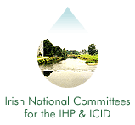
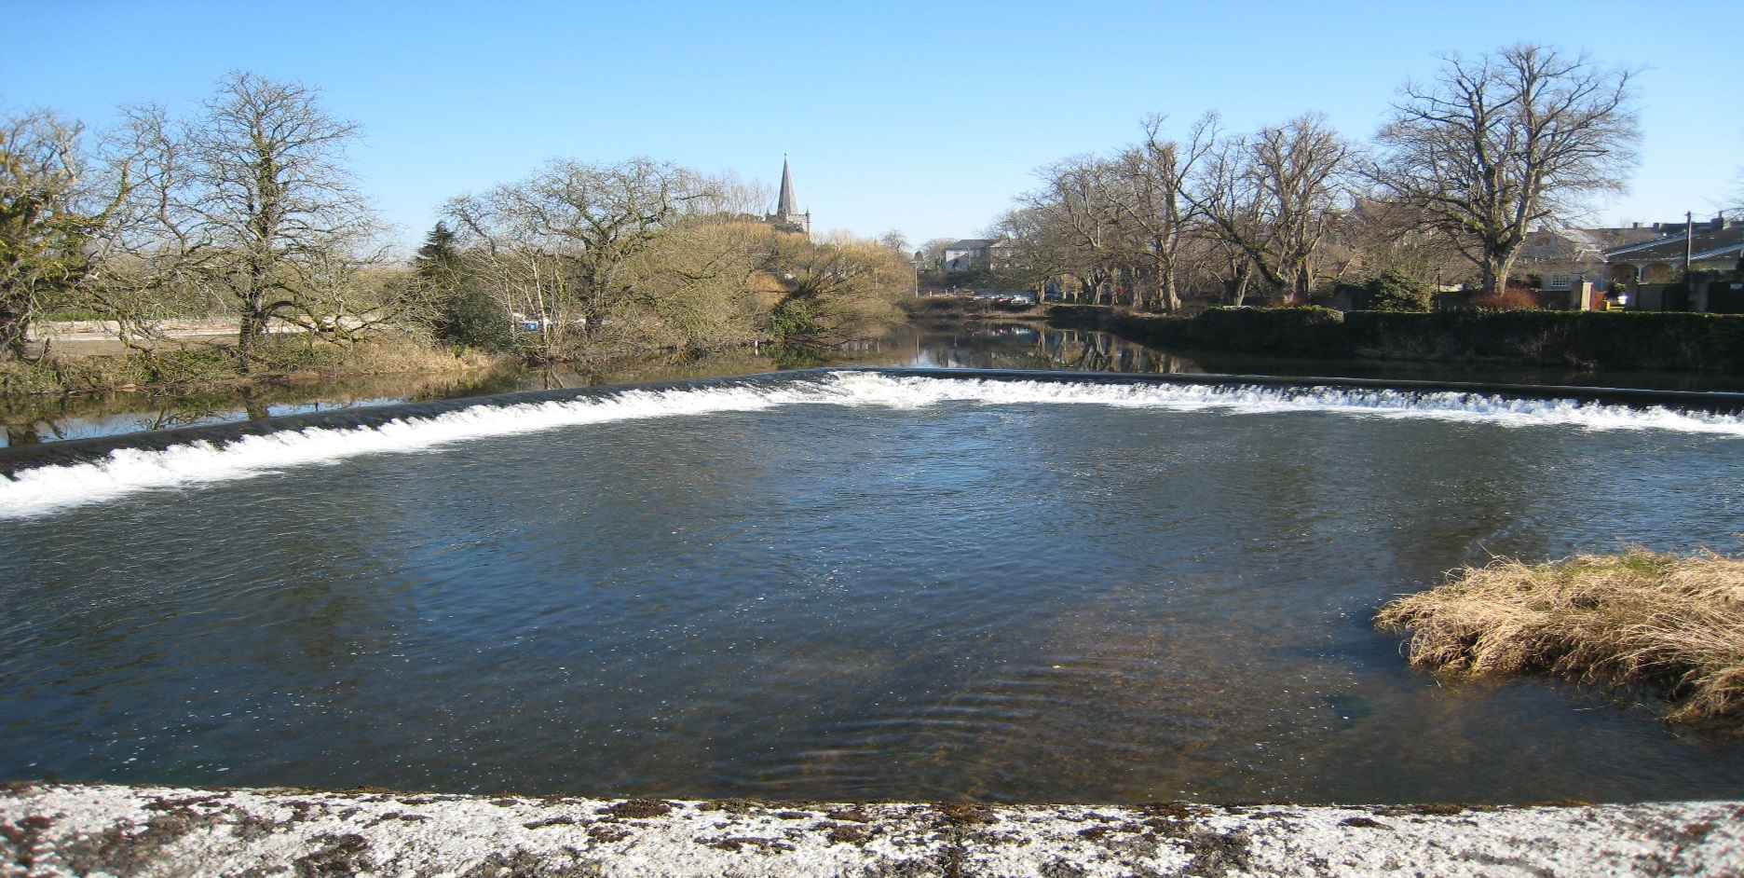
Irish National Hydrology
Conference 2021

First Announcement

Tuesday 16th November 2021
Hodson Bay Hotel
Athlone, Co. Roscommon

Introduction
The National Committees of the IHP/ICID invite you to Athlone for the 22nd National Hydrology Conference to be held on Tuesday 16th November 2021 at the Hodson Bay Hotel. This event is Ireland's leading Conference devoted to Hydrology providing a unique forum for attendees to share policy developments, research results, and practical solutions to engineering hydrology issues.

Conference Theme ..
It is widely said that global environmental change, such as climate change, land use change, etc., is noticeably influencing hydrological processes from catchment to regional and to global scales. In hydrology, practitioners apply scientific knowledge and mathematical principles to solve practical problems relating to hydrological processes including water, floods and droughts, erosion and sediment transport. They also benefit from a wider range of new data sources, from new sensor technologies and sensing platforms. In view of the increasingly complex scope of water related projects, a sound knowledge of the classical as well as the most modern analytical techniques applied in this field of physical hydrology or engineering hydrology is indispensable.

Organisers
International Hydrological Programme (IHP) .
The UNESCO international scientific co-operative programme in hydrology and water resources, the IHP, was established to act as a catalyst to promote co-operation and research in the management of water resources, an issue which had been identified as a significant limiting factor for harmonious development in many regions and countries of the world.

International Commission on Irrigation and Drainage (ICID)
The mission of the ICID is to stimulate and promote the development of the management of water and land resources for irrigation, drainage, flood control and river training applications, including research and development and capacity building.
Conference Booking & Costs .
Demand for places at previous Conferences has been high. Places are allocated on a first-come basis, and pre-booking is essential (using the registration form on this page). The cost of attendance at the Conference is €125 per person (with a limited Student rate of €40), which includes refreshments and lunch. Invoices will be issued following receipt of registration forms requesting the reservation of a place. Receipts will only be issued upon demand.

Please note that we there will be no refund or waiver of invoice for cancellations received later than Friday, 12th November.

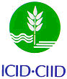

Irish National Hydrology
Conference 2021

Conference Opening
09:00  10:00 | Conference Registration (Tea, Coffee & Pastries)  Welcome – Patrick O'Donovan, T.D., Minister of State for the Office of Public Works and Flood Relief.

Session 1: ENVIRONMENTAL HYDROLOGY – RISK ASSESSMENT
10:20 | The importance of the riparian zone and in-stream processes in nitrate attenuation in undisturbed and agricultural watersheds – A review of the scientific literature  Anthony J. Ranalli (US Geological Survey)
10:40 | Herbicides in Irish rivers – Hydrology is only part of the picture  Michael Bruen (University College Dublin)
11:00 | Conference Poster Presentation
Brief Introductions to posters on display in the
exhibition area
11:15 | Discussion - Tea/Coffee

Session 2: REMOTE SENSING APPLICATIONS
12:10 | Drought monitoring, Precipitation statistics, and water balance with freely available remote sensing data: examples, advances, and limitations Angelos Alamanos (Dundalk Institute of Technology)
12:30 | Accuracy Assessment of LULC Change Detection in Burdur Watershed: Comparing Active and Passive Remote Sensing
 | M. Matin Saddiqi (University College Dublin)
12:50 | Surface water mapping and extraction methods using remote sensing data: a comparative study in Vojvodina (Northern Serbia)
 | Marta Estanqueiro (University College Dublin)
13:10 | Discussion – Lunch

Session 3: CLIMATE CHANGE ADAPTATION
14:15 | Hydrological Models for Climate Change Attribution of Extreme Weather Events in Ireland Paul G. Leahy (University College Cork)
14:35 | Climate Change Adaptation Plans for Flood Relief Schemes  Cian Buckley (Arup)
14:55 | Basing Flood Defense Planning on Realistic Data for Sea Level Rise  Ray Bates (University College Dublin)
15:15  15:25 | Discussion – Q&A  Comfort Break

Session 4: FLOOD RISK MANAGEMENT TOOLS
15:40 | Multi-scale monitoring in the Irish National Soil Moisture Network: call for collaboration
 | Tamara Hochstrasser (University College Dublin)
16:00 | Automated Flood Frequency Analysis for Ireland
 | Oliver Nicholson (Office of Public Works)
16:20 | Discussion – Q&A
16:30 | Close

Registration / Further Information .
To register to attend the conference or to request further information, please complete the registration form and return (with payment to confirm a booking) to:
Contact: IHP/ICID Secretariat,
Office of Public Works, Head Office,
Trim, Co. Meath, Ireland.
Tel: (046) 942 2472
E-mail: nhc@opw.ie
All payments to be made by Electronic Fund Transfer (EFT)
BIC - DABAIE2D
IBAN - IE91DABA95167890052841
Please send remittance to receipts@opw.ie and reference the National Hydrology Conference.

Registration Form
Name:
Job Title:
Organisation:
Address:
Purchase Order No. (if applicable):
Tel: Fax:
E-mail:

